Paper Title (24 pt, Bold, Title Case)

Name of 1st Author ¹, Name of 2nd Author ² (10 pt, Bold, Title Case)

¹ Designation of 1st Author, Name of Department of 1st Author, Name of Organization of 1st Author
² Designation of 2nd Author, Name of Department of 2nd Author, Name of Organization of 2nd Author
Corresponding author should be marked as * and email id should be mentioned of only corresponding author

1.Abstract:

- The abstract should summarize the objective, methodology, major findings, and conclusion.
- Avoid citations and abbreviations in the abstract.
- Provide 5–6 relevant keywords separated by commas.
- 200-300 words
- Font size-12, Times New Roman
- Spacing-1.5

Keywords: Keyword 1, Keyword 2, Keyword 3……………. Keyword 8

2. Manuscript Formatting

General Format
- Heading- 12, Bold; Hierarchical numbering, for heading (for example - 1.) and for sub-headings (for example – 1.1, 1.2).
- Content Font size- 12
- Font- Times New Roman
- Line Spacing-1.5
- Alignment- Justified

3. Structure of the Manuscript/ Paper
The manuscript should be arranged in the following order:
Research Article-
- Title
- Author(s) and Affiliation(s)
- Abstract (200–300 words)
- Keywords (5–6 keywords)
- Introduction
- Materials and Methods
- Results
- Discussion
- Conclusion
- Acknowledgements, Funding Information, Author Declaration (if any)
- References
- Appendices / Supplementary Material
Review Article-
- Title
- Author(s) and Affiliation(s)
- Abstract (200–300 words)
- Keywords (5–6 keywords)
- Introduction
- Keywords
- Introduction
- Literature survey
- Custom sections
- Discussion
- Conclusion, Future prospects
- Acknowledgements, Funding Information, Author Declaration (if any)
- References
- Appendices / Supplementary Material
Note- The length of the full paper should be maximum 8000 words including references.

4. Tables and Figures

- Each table should have a title above the table.
- Each figure should have a caption below the figure.
- Graphical representation/images must be of high resolution (minimum 600 dpi).
- Graphical representation must not be copy and paste
- Instead of using short text like “Fig. 1”, use full text like “Figure 1” in captions.

Table 1: Table Type Styles
 | Column Heading 1 | Column Heading 2 | Column Heading 3
Row Heading 1 | 184 | 456 | 323
Row Heading 2 | 290 | 234 | 523
Row Heading 3 | 427 | 149 | 785
Total | 901 | 839 | 1631

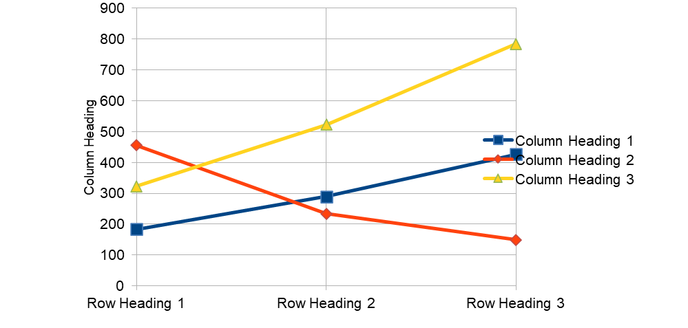
Figure 1: Temperature After Each Pass

5. References

References within Main Content of the Research Paper
- Enclose the citation number in square brackets, for example: [1].
- Authors must ensure that all references cited in the text are included in the reference list, and that all references listed are cited in the text.
Examples:
- Single reference: [1]
- Multiple references: [2,3] or [2–5]

References in the Reference List at the End of the Research/Review Paper.

- References list details may be added at the end of the paper
- DOI number addition in references is mandatory wherever applicable

Example:

Research Article reference-

- Grady, J. S., Her, M., Moreno, G., Perez, C., & Yelinek, J. (2019). Emotions in storybooks: A comparison of storybooks that represent ethnic and racial groups in the United States. Psychology of Popular Media Culture, 8(3), 207–217, 10.1037/ppm0000185

Book Reference-

- Brown, T. A. (2022). Gene cloning and DNA analysis: An introduction (8th ed.). Wiley-Blackwell.

Magazine references

Doi link can be added (recommended)- https://doi.org/10.1037/ppm0000185

